**SPRINT 2**

**TEAM ID:** PNT2022TMID16894

**PROJECT NAME:** REAL-TIME RIVER WATER QUALITY MONITORING AND CONTROL SYSTEM

**DATE:** 19-11-2022

**Summary:**

In this sprint, the following are done:

1. Sound effects added in the MIT platform (phone app)
2. Phone UI is made better
3. Data in the backend is scrutinized to match real-world case.

**CODE:**

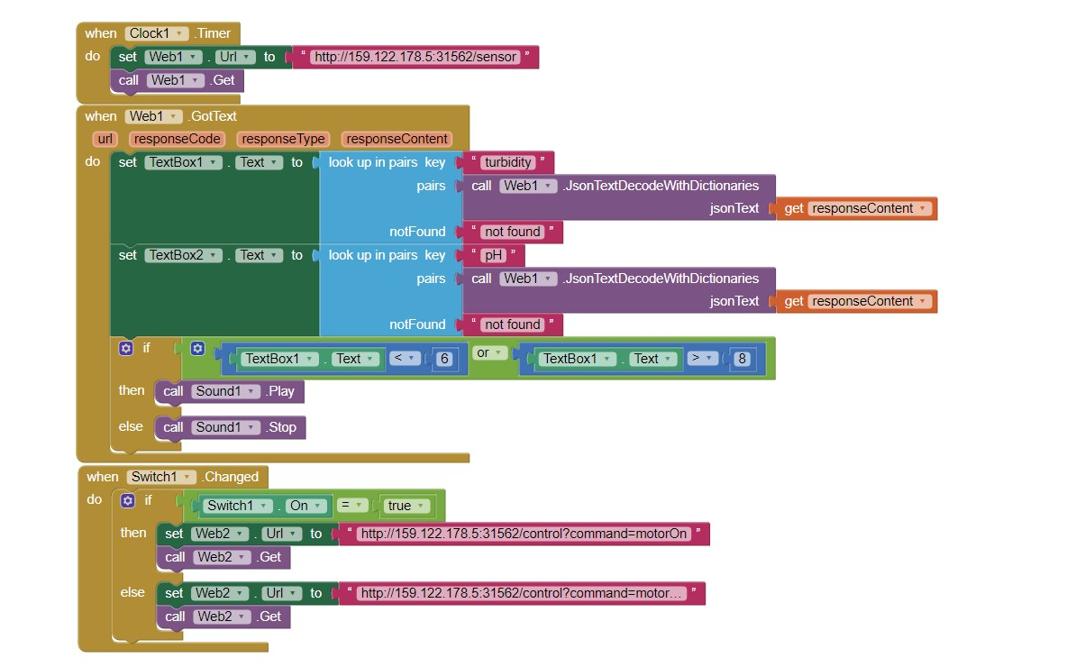

**Python code:**

(main loop): while True:

pHIndex = random.randint(0,13) pH pHList[pHIndex] if pH <= 8 and pH >= 6:

print("relax") else: print("alert")

turbidity = round(random.uniform(0.1,1.0),2) data = {'pH':pH , 'turbidity':turbidity} print(data) def onPublishCallBack(): print("success") success = deviceClient.publishEvent("IotSensor","json",data,qos=0,on_publish=onPublishCallBack)

if not success: print("not connected") time.sleep(1)

deviceClient.commandCallback = myCommandCallBackdeviceClient.disconnect()

**UI:**

